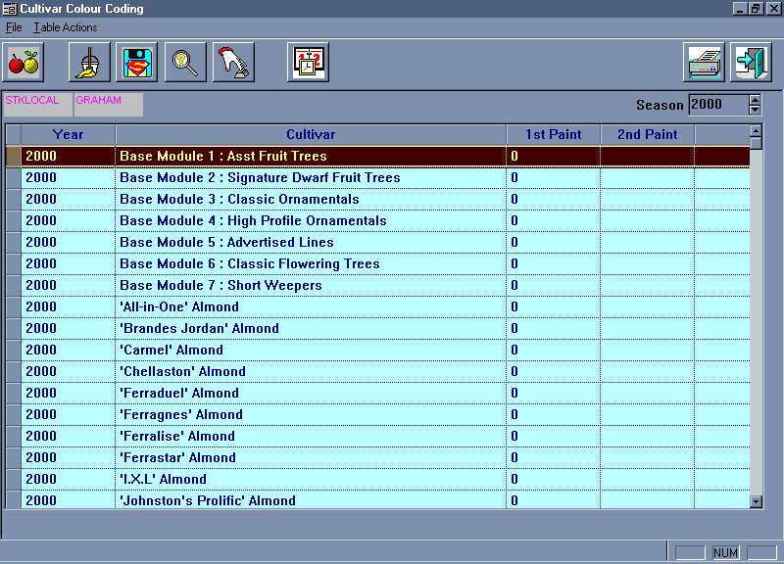

The above screen is the Colour Coding program that has just been created. It simply lists the year, cultivar description, paint one and paint two. From this screen you can perform 2 basic functions:

- Print the colour coding listing
- Reset all of the colour codes for the current season.

Below is a breif discussion of each button and its purpose.

